**How Team12 added libraries for our Eclipse Project**

Background: we used two libraries so far: Apache.csv and CoreNLP. We had a difficulty configuring our Eclipse project with setting up with libraries. We thought it would be helpful for us to leave documentation regarding how we connected to external resources.

For both Apache.csv libraries and CoreNLP jar files, we went to Configure Build Path.

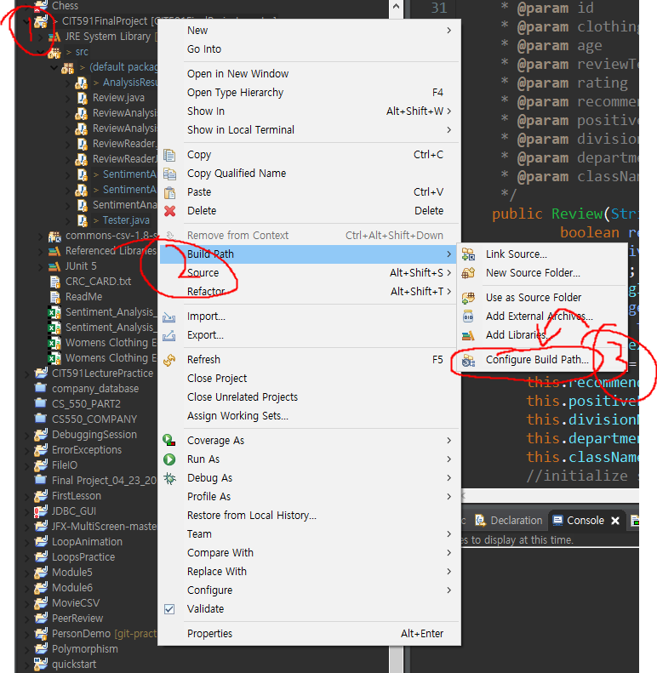

**CoreNLP Jars-**

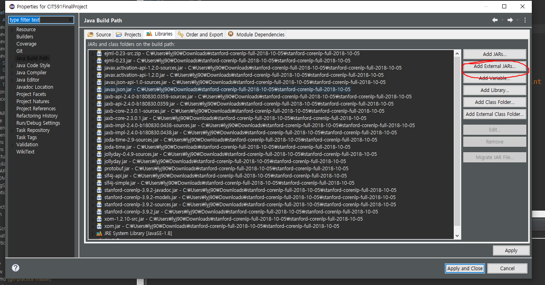

From Libraries tab, we clicked Add External JARs file then added all the jar files from stanford-corenlp-full-2018-10-05.zip files.

**Apache CSV Library-**

1. Go to the **Source** tab.
2. Click Link Source.
3. After hitting Browse button, browse to where you stored “common-csv-1.8src.”  
   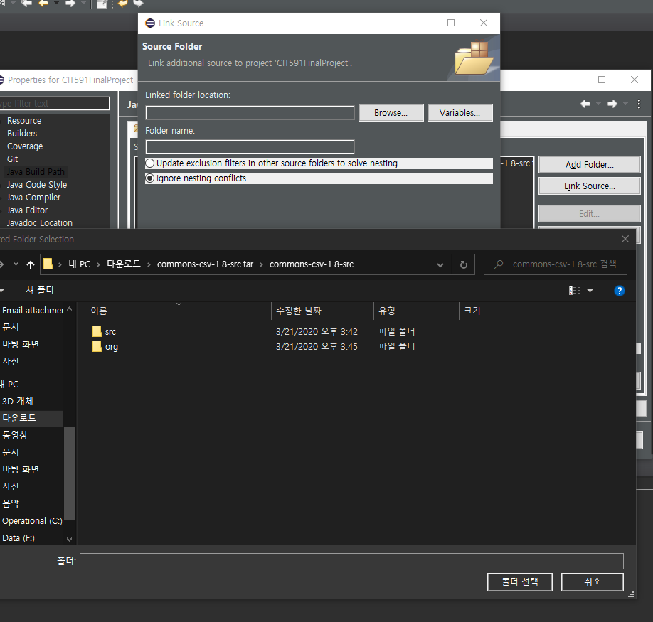
4. Click select folder and check “Update exclusion filters in other source folders to solve nesting.”

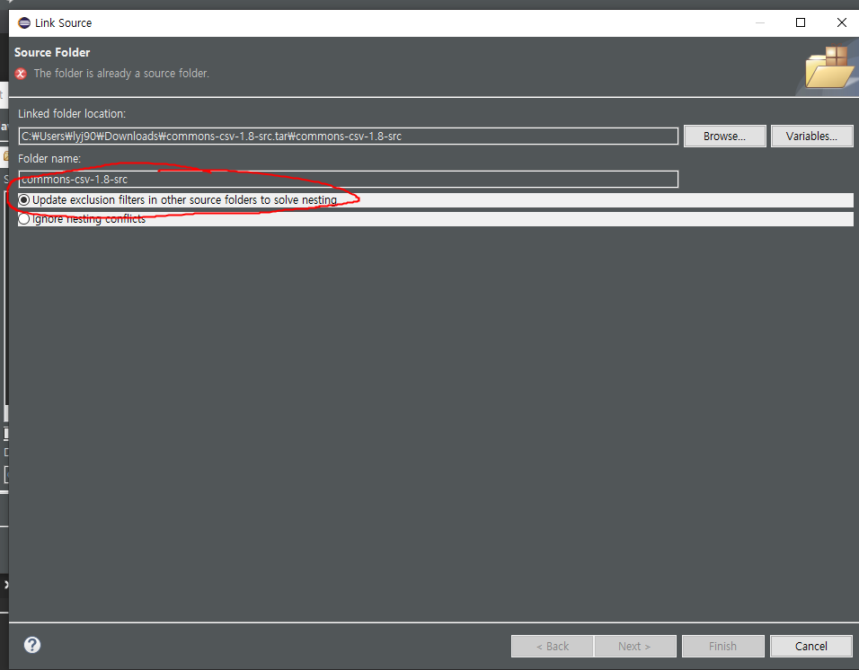

1. Then click **Finish.**

JfreeChart

1. Go to Build Path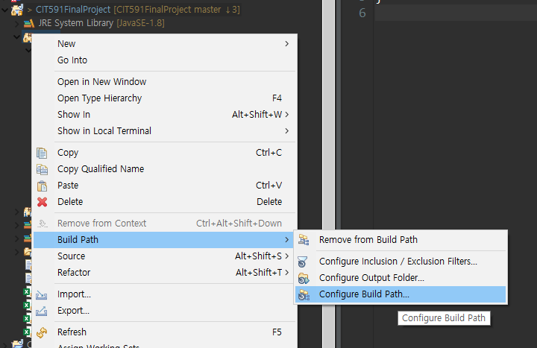
2. Hit Add External JARs button.
3. Locate jfreechart-1.0.19.jar and jcommon-1.0.23.jar files then add it to the build path:
4. 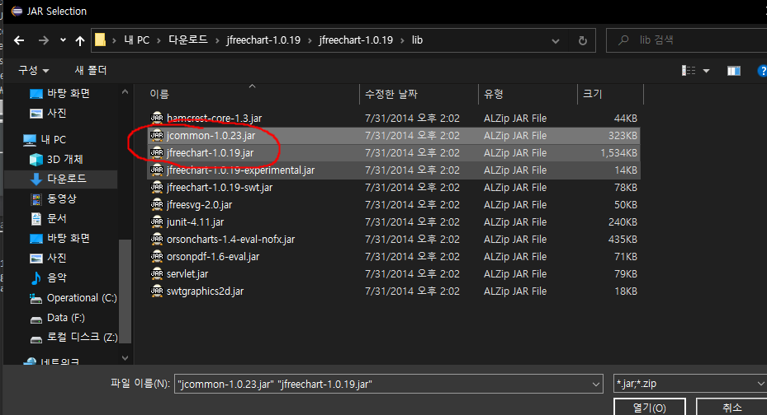
5. Hit Apply and Close